**Physical and human geography in Charmouth, Dorest.**

**Charmouth**

**FPS Geography**

**KNOWLEDGE ORGANISER**

**Vocabulary**

|  |  |
| --- | --- |
| **Coastline** | Coastline or seashore, is the area where land meets the ocean. |
| **Fossil** | Fossils are the remains or traces of plants and animals that lived long ago. |
| **Herbivore** | An animal that feeds on plants. |
| **Carnivore** | An animal that feeds on meat. |
| **Jurassic** | Dinosaurs lived during three periods of time - the **Triassic** period**,** the **Jurassic** period, and the **Cretaceous** period. |

|  |  |
| --- | --- |
| **Uk Dinosaurs** -Can we use a map to find where in the UK these Dinosaurs were found? | |
| **Ankylosaurus**   | Ankylosaurus measured up to6m in length and nearly 2m tall. It was an armoured dinosaur. |
| **Sauropod**  See the source image | A very large **herbivore** dinosaur with a long neck, tail and a small head. Sauropods were the largest dinosaurs ever to walk the earth. |
| **Stegosaurs**   | The stegosaurs were a group of armoured dinosaurs with bony plates which ran along their back. |

**Yr 1/2 Where in the UK can we find Dinosaurs?**



Geography Investigators: What was the biggest Dinosaur found in the UK?

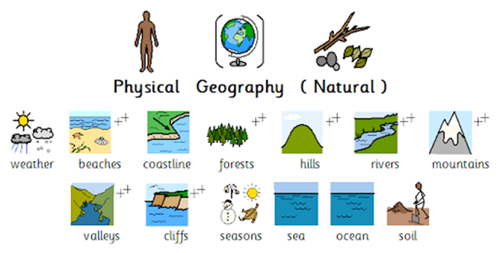

**Nottingham**

**Charmouth**

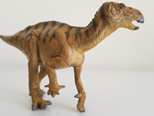

**Charmouth** is a village in **Dorest**, England. It has a beach and is famous for its large amount of dinosaur **fossils**. **Scelidosaurus** is the most complete dinosaur found so far in Britain. It is only found here at **Charmouth** and nowhere else in the world. 