Nelson Mandela and Rosa parks
Year 1/2 How have Nelson Mandela and Rosa Parks helped to make the world a better place?
FPS HISTORY
Knowledge Organiser

History Detectives: How might life be different now without these important people?
Nelson Mandela
Nelson Mandela (1918-2013) was a South African politician. He was the President of South Africa between 1994 and 1999.  He campaigned to make things fair and equal, and because of this spent 27 years in prison.  He was the first President of South Africa to be voted for by all people, black and white.  He worked to remove the old system of racism in South Africa (called apartheid) and to make the country fair and safe for everyone.  He won the Nobel Peace Prize  and was given many awards for his bravery and courage. | 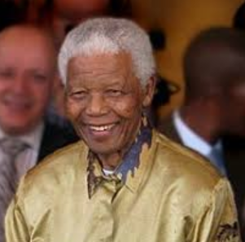 |  | Campaigner | A person who works towards a goal
 |  |  | President | The head of a place or country
 |  |  | Racism | Treating people differently because of their skin colour or beliefs
 |  |  | Apartheid | A law in South Africa where people were separated because of their skin colour
 |  |  | Equality | Being equal in what you are allowed to do
 |  |  | Protest | People coming together in a public place to say no to something they think is unfair
 |  |  | Government | A group of people who work with a leader to make laws for a place or country
 |  |  | Nobel Peace Prize | An award given for outstanding work in making peace in the world
 |  |  | ANC | African National Congress - South Africa’s governing party since 1994  1994-99: Mandela is President of South Africa.  5th December 2013: He dies aged 95 in Johannesburg.
Important Times
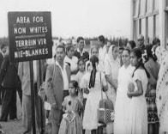
Apartheid
- In 1948, the South African government created apartheid. This was a law that meant that white and black people had to live separately.
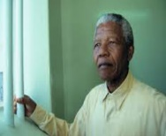
Imprisonment
- Because of his role in going against the government, Mandela was sentenced to life in prison. He served 27 years in prison in total, 18 of them on Robben Island.
-People from all over the world began a campaign to get Nelson Mandela released from prison. Eventually, in 1990, he was freed.
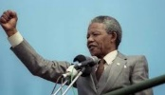
Time as President
- On 10th May 1994, Nelson Mandela became the first black President of South Africa, aged 77.
- Throughout his time as President, he made many new rules to try and make sure the country stayed fair.
Rosa Parks
- Rosa Parks was brought up on a farm in Alabama, USA. She wanted equal rights for black and white people.  - In 1955, the driver of a bus wanted her to give up her seat to a white person. She said no and was arrested.  - After that, black people in her town decided to try to stop the bus service.  - Lots of people supported her and stopped using the bus. | - As a result of her actions, United States Court ruled that black and white people would be allowed to sit together on the bus.  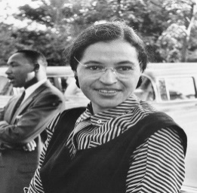  - Rosa continued working to improve the rights for black people in Alabama and as a result she became known as “the mother of the freedom movement.”
Nelson Mandela Timeline
1993: He jointly wins the Nobel Peace Prize.
1990: After a major campaign, he is released from prison.
1963: Mandela is sentenced to life in prison.
1939: He goes to University College.
18th July 1918: Nelson Mandela is born.
1940-42: Mandela runs away to Johannesburg and joins the ANC.
1948: The South African government introduces apartheid.
1949: The ANC begins peacefully protesting the apartheid.
Key Vocabulary

