**Year 5/6 Why is the Rainforest essential for a healthy planet?**

**FPS GEOGRAPHY**

**Knowledge Organiser**

**Key Vocabulary**

|  |  |
| --- | --- |
| carbon dioxide | a green house gas that traps heat in the earth’s atmosphere |
| climate change | how weather and climate are changing |
| deforestation | the cutting down of a large area of trees |
| ecosystem | a community of plants and animals that depend on each other to survive |
| endangered | likely to become extinct |
| equator | an imaginary line that divides the earth in half, horizontally |
| extinction | an animal or plant that no longer exists |
| humid | a high level of moisture in the air |
| indigenous | a living thing that belongs naturally to one area |
| interdependent | needing others to survive |
| rainforest | a dense forest with high rainfall and humidity |

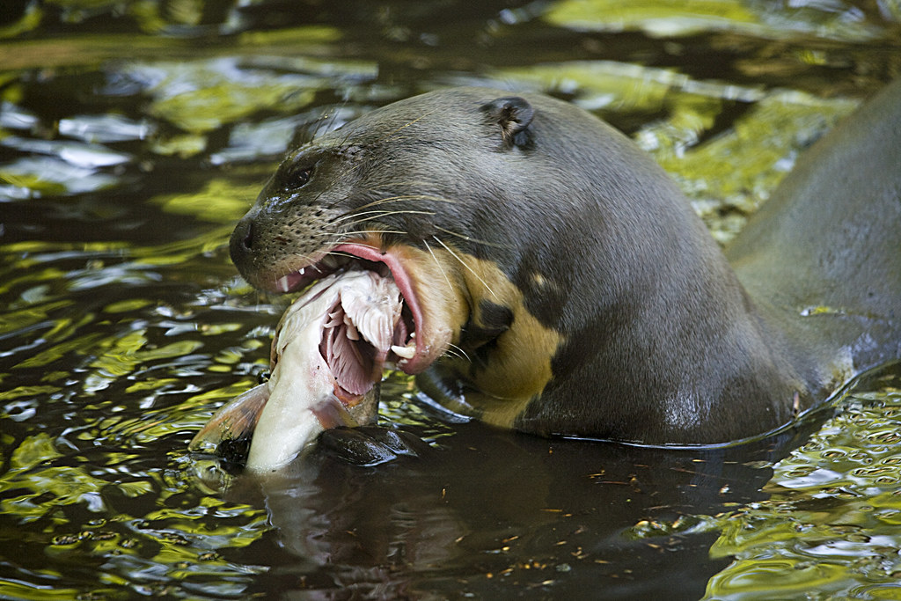

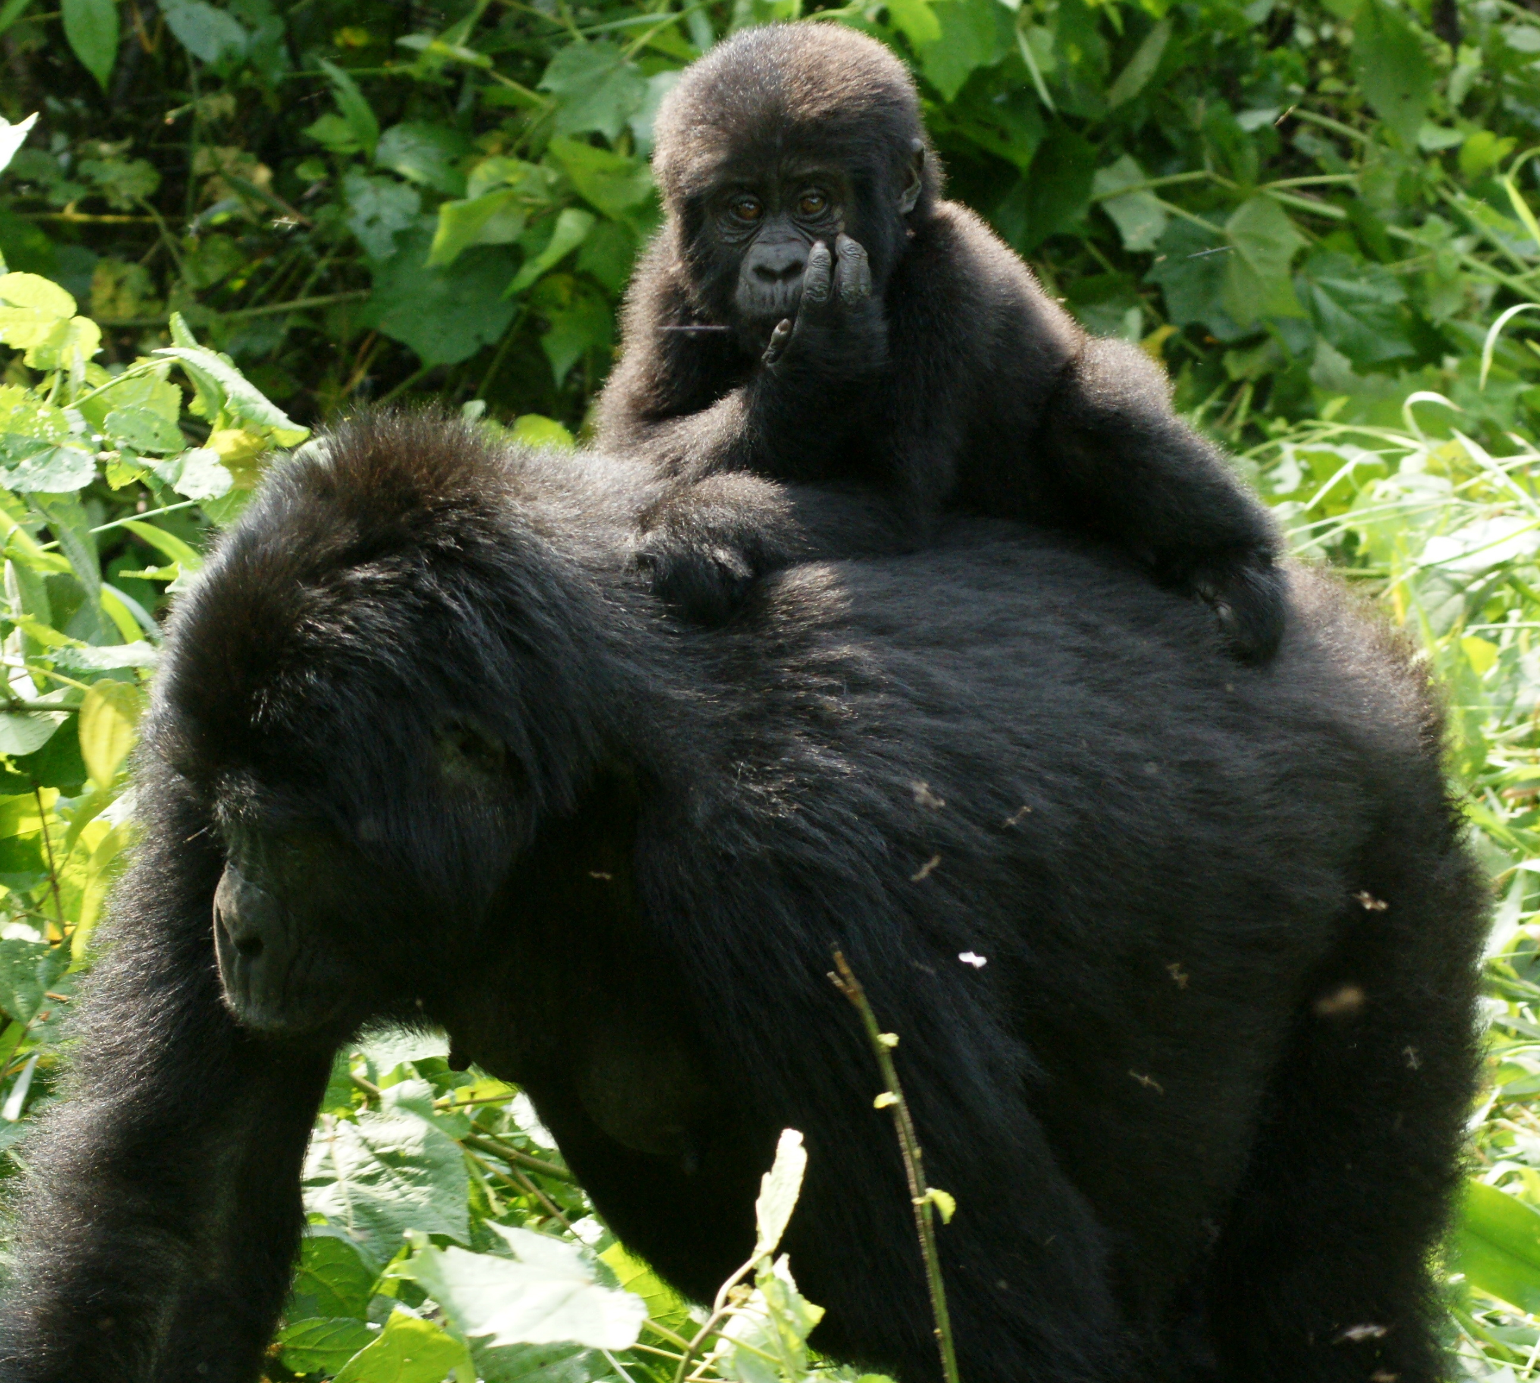

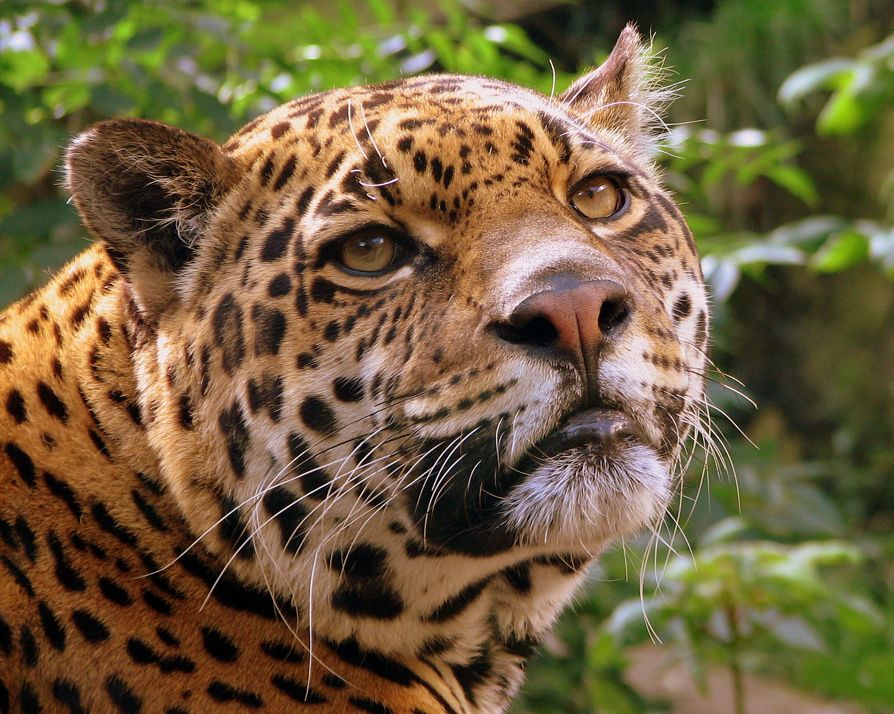

**Key Question: What makes a rainforest?**

Key Learning: Rainforests get between 200cm to 450cm of rain a year. They are very humid and warm, staying around 21 to 32 celsius a year. These conditions make for excellent plant and animal growth.

**Key Question: What animals are endangered that live in the rainforest?**

Key Learning: There are currently over 2500 species near extinction including jaguars, giant otters and gorillas.

**Key Question: How does the rainforest benefit the world?**

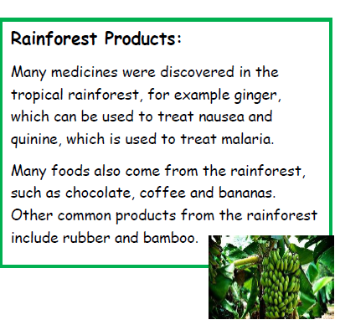

**Key Question:** Where are the rainforests located?

Key Learning: The majority of rainforests lie between the tropics of cancer and capricorn which are imaginary lines drawn on the map of the earth.

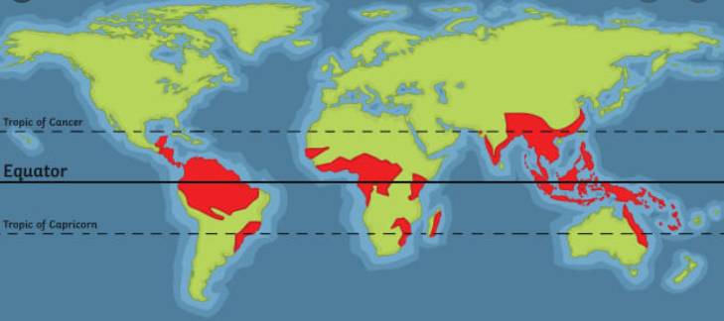

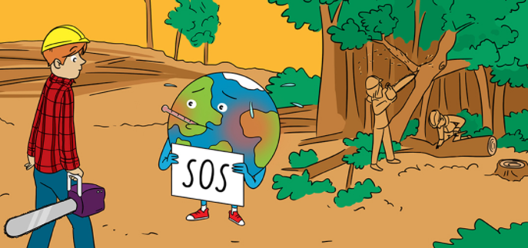

**Key Question: What is deforestation**

**Key Learning:** Deforestation is the planned clearing of mass areas of forest.

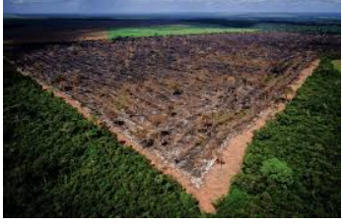

**Key Question: What are the two types of rainforest?**

There are two types of rainforests, tropical and temperate. Tropical rainforests are found closer to the equator where it is warm. Temperate rainforests are found near the cooler coastal areas further north or south of the equator.

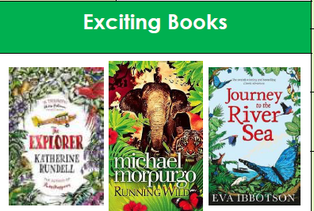

**Key Question: What are the layers of a rainforest?**

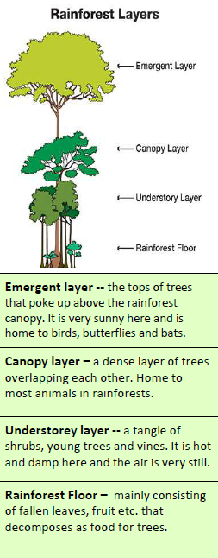

**Key Question: How is the Earth’s**

**climate linked to the rainforest?**

Key Learning: Trees absorb carbon dioxide and produce oxygen which we breath. They are known as the lungs of the Earth.