Key Vocabulary
Physical Geography | Natural features not made by people - seas, mountains and rivers.
Human Geography | Things that have been made by people -bridges, roads houses.
Temperate | Mild, gentle temperatures. Not too hot or too cold.
Equator | The imaginary circle around the earth that is halfway between the North and South Poles.
Climate | A climate is similar to the weather, but over a long time.
Tropical | A climate near the equator that is hot and moist year-round.
Biome | A biome is a large area of the Earth that has a certain climate and certain types of living things.
Produce | To make or grow food usually in large amounts.
India | A country in South Asia
Rainforest | A forest of large evergreen trees that has a lot of rainfall.
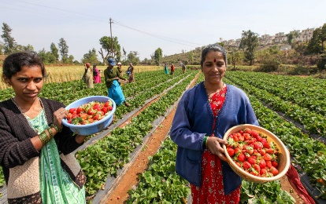
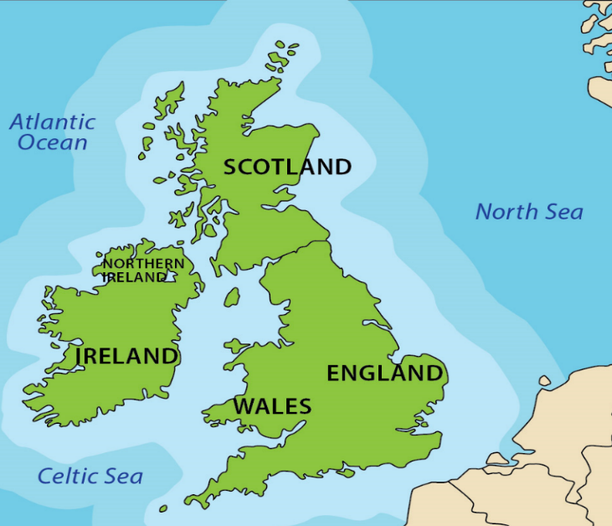
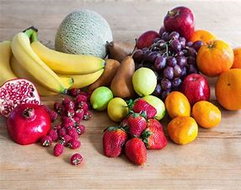
India-India has a climate that is perfect for growing many fruits and vegetables all year round.
Most of the country has a tropical climate which tends to be a mixture of hot, dry and wet weather which is perfect for growing many foods.
UK -The UK has a temperate climate. This means that Britain gets cold, wet winters and warm, wet summers.

FPS GEOGRAPHY
Knowledge Organiser

Year 1/2-Food and India 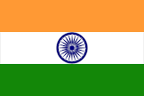
Geography Detectives:
Why does India grow so much fruit?

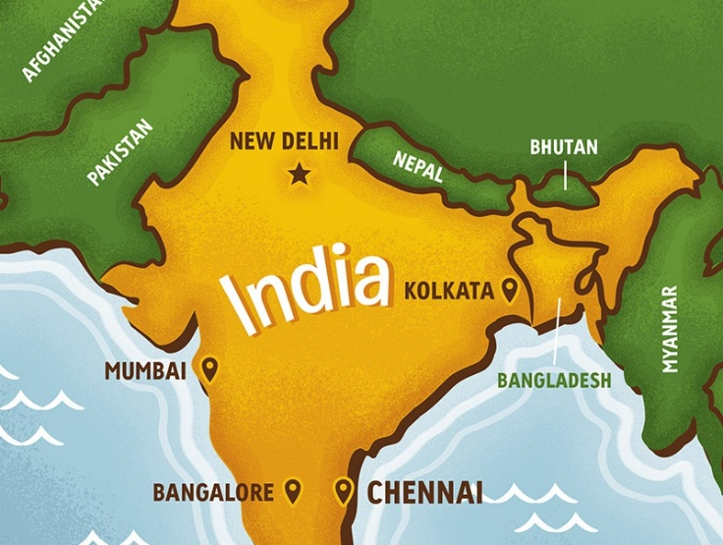
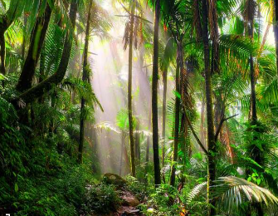
Biome of India -Tropical rainforest.
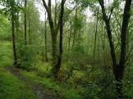
Biome of UK - Temperate forest.
