History Detectives:

What was Flintham like in the past?

**Year 1/2 How old is Flintham Village?**

**Key Vocabulary**

|  |  |
| --- | --- |
| **Artifact** | An object from the past that is made by a human being. It helps to tell us when something happened. |
| **Coaching Inn** | A resting point for people and horses. |
| **Coat of arms** | A symbol used to show a family name. |
| **Chronological** | A list of events in the order they happened |
| **Historians** | A person who studies and writes about the past. |
| **Museum** | A place where important objects from the past are kept |
| **Norman** | A period of time from 1066 until 1300. |
| **Roman** | A period of time around 2000 years ago. |
| **Settlement** | A new place where people settle to live. |
| **Victorian** | A period of time when Queen Victoria was England’s queen from 1837 until 1901. |

**Key Question:** How old is Flintham Church?

**Key Learning:** **The main tower part of St Augustines church was built in the Norman times in 1086. It’s nearly 1000 years old! Some of the building has been re-built, the left hand side was built almost 200 years ago.** 

**Timeline: Key Events**

|  |  |
| --- | --- |
| **-1000s**  **First part of Flintham Hall was built.** | [Flintham♥.•:*´¨`*:•♥Hall | Dream house exterior, Architecture, English  manor houses](https://www.google.com/url?sa=i&url=https%3A%2F%2Fwww.pinterest.com%2Fpin%2F53902526761666933%2F&psig=AOvVaw0FzL_CPyG5WGnrzc6rcyVA&ust=1630161504407000&source=images&cd=vfe&ved=0CAcQjRxqFwoTCNDI4fq20fICFQAAAAAdAAAAABAb) |
| **-1086 Flintham church was built.** |  |
| **-1600s**  **The Coaching inn ‘The Boot and Shoe’ was built.** | [A picture containing building, outdoor, brick, house  Description automatically generated](http://1.bp.blogspot.com/-AqOA786lNXw/VcIzSnkGEBI/AAAAAAAAB6I/BrarvSiqFvM/s1600/Flintham%2BBoot%2Band%2BShoe%2B%25281%2Bof%2B1%2529.jpg) |
| **-1779**  **Flintham museum was built.** | [DEN Project: East Midlands Food](https://www.google.com/url?sa=i&url=http%3A%2F%2Fwww.digitalengagementnetwork.org%2Feastmidlandsfood%2F2010%2F12%2F06%2Fflintham-museum%2F&psig=AOvVaw2hj8GRVHQc1LnxhaHSqBSr&ust=1630161851715000&source=images&cd=vfe&ved=0CAcQjRxqFwoTCLj90aG40fICFQAAAAAdAAAAABAD) |
| **-1874**  **The village hall was built.** |  |
| **-1960s**  **Flintham Primary school was built.** |  |
|  |  |

Hacker family coat of arms

In 1779 money was raised for a school building. It is now the Flintham museum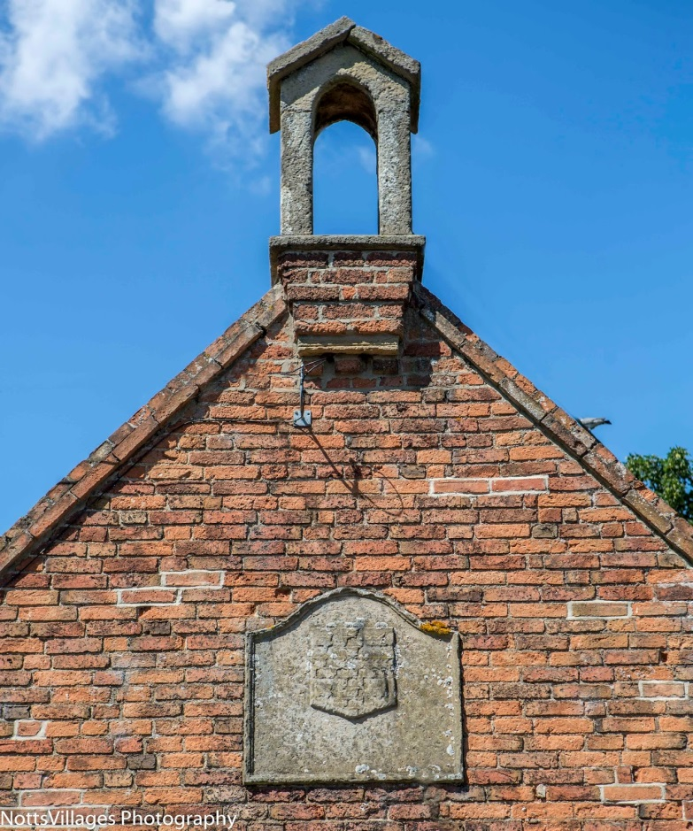

The Robert Hacker School was replaced by a newer school in 1874. This was a school until the 1960s. It is now the Village Hall. 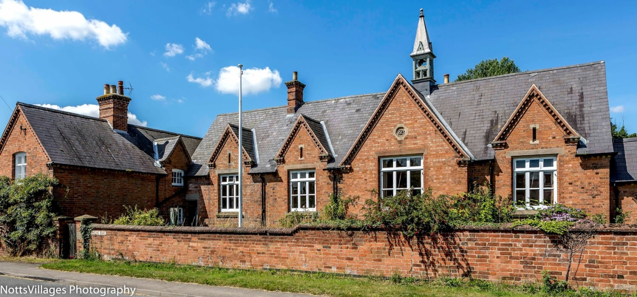

**Flintham Hall**

**Flintham Church**

**Key Question:** Where did children go to school in Flintham?

**Key Learning: The Hacker family from Flintham Hall paid for school lessons for the poor people of Flintham. Lessons took place in Flintham church.**

](https://en.wikipedia.org/wiki/File:Flintham_Hall_(geograph_2843189).jpg)

**Key Question:** When did life in Flintham begin?

**Key Learning: Historians believe Flintham village dates back to the Roman times.

**1828**

**1086**

**Flintham in Victorian times.**

**FPS HISTORY**

**Knowledge Organiser**