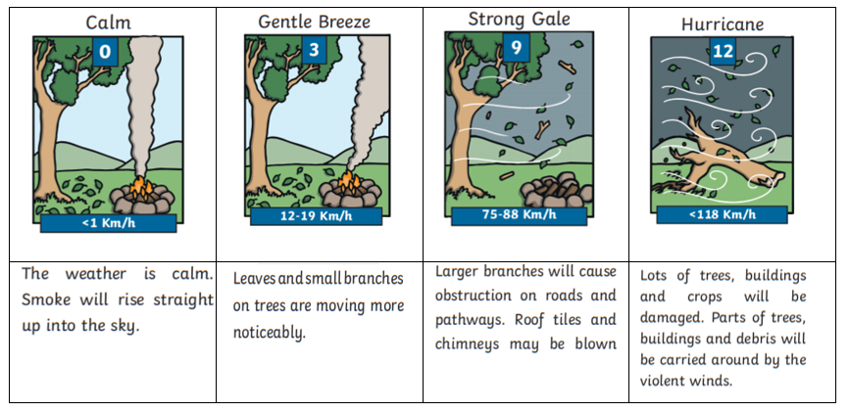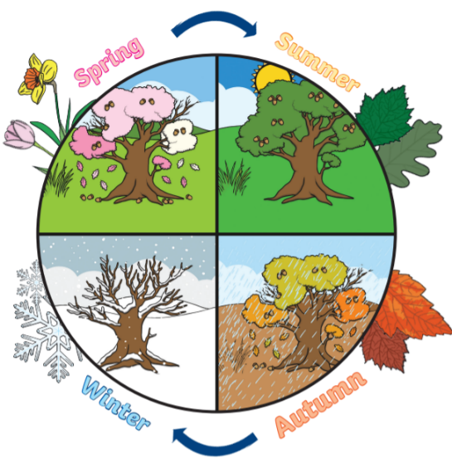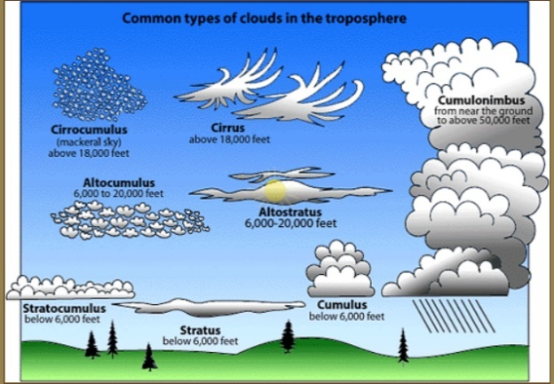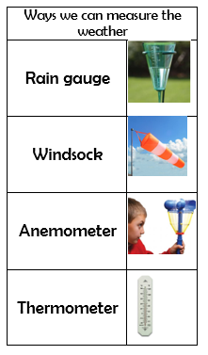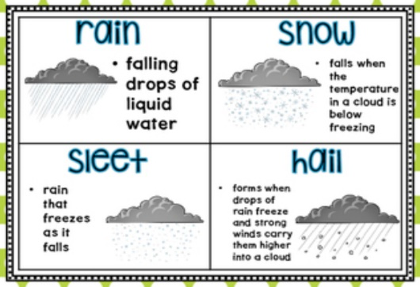

**There are more hours of daylight in the summer than in the winter.**

**FACTOID**

Wind had different names depending on how fast it blows.

**There are different types of clouds**

**FACTOID**

Looking at clouds helps weather scientists called Meteorologists know what type of weather is coming.

**Precipitation**

**Vocabulary**

|  |  |
| --- | --- |
| Spring | Spring is the [season](https://kids.britannica.com/kids/article/season/399589) when cold [winter](https://kids.britannica.com/kids/article/winter/623335) temperatures gradually rise. Spring is a time of new plant growth. It is also when animals become active again after the winter. They begin to nest. |
| Summer | Summer is the warmest [season](https://kids.britannica.com/kids/article/season/399589) of the year. It is the time of the greatest plant growth. The hours of daylight are longer in the summer. |
| Autumn | In Autumn, the weather begins to get colder. Leaves change colour and fall from trees. Animals begin to prepare for winter. They grow thicker coats or store food for the coming winter. |
| Winter | Winter is the coldest [season](https://kids.britannica.com/kids/article/season/399589) of the year. The days become shorter and the nights become longer some plants die, leaving their seeds, and others stop growing until spring. Many animals hibernate. |
| gale | A very strong wind of about thirty to sixty miles per hour. |
| breeze | A light or gentle wind. |
| precipitation | Water that is released from the sky, it can be liquid or solid. Rain, sleet, hail and snow. |
| anemometer | A wind speed meter. They measure the speed of wind by counting how fast a set of wind cups or wind blades move in a circle. |

Super Scientist Investigates:

Where does rain come from?

**FPS SCIENCE**

**KNOWLEDGE ORGANISER**

**Year 1/2 Weather – Does weather change with the seasons?**