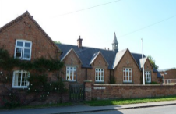
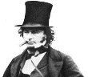
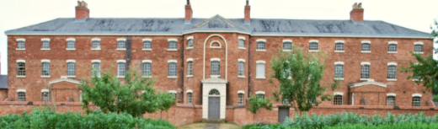
Key Question:How did the Victorian era change the lives of children?
Key Learning:
- Industrialisation changed Britain as farmers to manufactorers.
- Technological advances- communication, engineering, transport, science, medicine
- It was made compulsory that all children attend school from ages 5-12.
- Laws were passed to protect working children from long hours and terrible working conditions.

Isabambard
Kingdom Brunel
Engineer
1806-1859

Why were these Victorians so important?
Timeline: Key Events
1837 | Queen Victoria becomes queen
1838 | Slavery abolished in the British Empire  QV crowned queen
1840 | Queen Victoria marries Prince Albert
1842 | The mine act means children under 10 can no longer work in coal mines
1851 | The Great Exhibition takes place from May and October in London
1861 | Prince Albert dies of typhoid
1864 | Children under 10 can no longer work as chimney sweeps
1870 | Schools start being built for 5-10 year olds
1880 | The Education Act makes school compulsory for all children
1901 | Queen Victoria dies, aged 81 and Edward vii becomes king

Key Question:What was it like for rich and poor children living in Victorian Flintham and the surrounding area?
Key Learning: The importance
of wealth in the V. era. To
learn about the local workhouse and what daily life was like for inmates.

Key Question: How was schooling different
for a Flintham child in the Victorian era?
Key Learning: To find out when Flintham school opened and the main differences between schooling in Victorian v modern times.

Key Question: Who was Queen Victoria, why was she so important and when was the Victorian era?
Key Learning: Chronolgically order main periods of British history and the main events in within Victorian times.
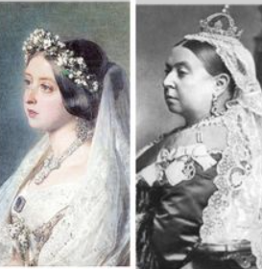

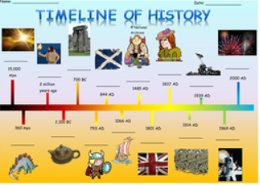
Key Vocabulary
industrialisation | the change from making things with hands to using machinery
industrial revolution | the period of history when industrialisation took place
The Great Exhibition | a showcase of culture and industry
manufacture | make something on a large scale using machinery
textiles | flexible materials made by weaving yarns or threads
the workhouse | a place where poor people would go to live and work
compulsory education | it is law for children to attend school
corporal punishment | force used against a child to control or correct behaviour

History Detectives:
How have the lives of children changed because of the Victorian era?
Year 3/4 Would you rather be a child in QV’s reign or King Charles III reign?
FPS HISTORY
Knowledge Organiser

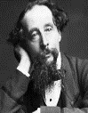
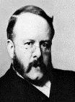
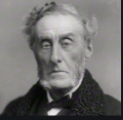
Charles Dickens
Writer
1812-1870
Thomas
Barnado
Doctor/set up homes ‘poor’ homes’
1845-1905

Lord
Shaftesbury
Politician
and Social
Reformer
1801-1885
Key Question: What different jobs may working Victorian children have done living in Flintham and the surrounding area?
Key Learning: The jobs local children may have done and other jobs in Nottinghamshire such as textile mills, mines and lace factories.

The Victorians
The Victorians

The Victorians
The Victorians

The Victorians
The Victorians

Timeline: Key Events

1842 The mine act means children under 10 can no longer work in coal mines

1838 Slavery abolished in the British Empire and QV crowned queen

1901 Queen Victoria dies, aged 81 and Edward vii becomes king

1840 Queen Victoria marries Prince Albert

1851 The Great Exhibition takes place from May and October in London

1870 Schools start being built for 5-10 year olds

1864 Children under 10 can no longer work as chimney sweeps

1861 Prince Albert dies of typhoid

1837 Queen Victoria becomes queen

1880 The Education Act makes school compulsory for all children

