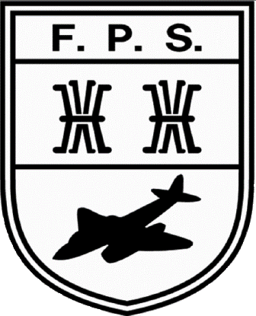
Flintham Primary School
Whole School Curriculum Topic Overview Two Year Plan

Science Focus
Cycle A | Class 1 |  | Class 2 |  | Class 3 |  | Class 4
 | Autumn 1 | Body Parts and the 5 senses | Autumn 1 | Use of everyday materials | Autumn 1 |  | Autumn 1 | Light and the eye
 | Autumn 2 | Where does food come from? Autumn seasonal changes | Autumn 2 | Air power - va force to move | Autumn 2 | Rocks, soil and fossils | Autumn 2 | Electricity
 | Spring 1 | Basic properties of materials | Spring 1 | Animals around the world  Food chains | Spring 1 | Teeth, bones and digestion | Spring 1 | Evolution
 | Spring 2 | Things that Grow  Spring seasonal changes | Spring 2 | Seasons and the Earth | Spring 2 |  | Spring 2 | Classifying animals
 | Summer 1 | Woodland Habitat  Introduction to food chains and minibeasts | Summer 1 | Does a big seed grow a big plant? | Summer 1 | Light and sound | Summer 1 | The human body/Heart, lungs and circulatory system
 | Summer 2 | The sea  Summer seasonal changes | Summer 2 | Living and non-living things  Mini-beasts | Summer 2 |  | Summer 2 | Structure of a plant  7 Life processes/ Life cycles
Cycle B
 | Autumn 1 | Autumn seasonal changes including the weather | Autumn 1 | Ourselves and our amazing bodies  Keeping healthy through exercise | Autumn 1 |  | Autumn 1 | Materials  reversible and irreversible changes
 | Autumn 2 |  | Autumn 2 | Materials and their properties | Autumn 2 | Changing States of material  The Water Cycle | Autumn 2
 | Spring 1 |  | Spring 1 | Living and non-living things  Mini-beasts  Plants and their habitats | Spring 1 |  | Spring 1 | Micro-organisms
 | Spring 2 | The solar system  Push and Pull | Spring 2 | Healthy Food: Where does it come from? | Spring 2 | Magnets  Electricity | Spring 2 | Forces
 | Summer 1 |  | Summer 1 | Comparing dinosuars including herbivores with omivores | Summer 1 |  | Summer 1
 | Summer 2 | Different animal groups and their characteristics | Summer 2 | What’s in the sea? | Summer 2 | Animals in their environments  Growing plants | Summer 2 | The Earth, Sun and Moon

